West Virginia Division of the Society of American Foresters
November 2020 Newsletter
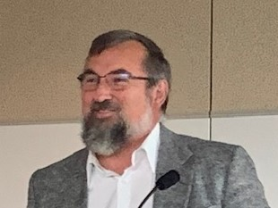

From the Chair…………….

This year has brought many challenges and changes to each of us individually, our Society (of American Foresters) and society. Our inability to gather has left many feeling isolated and alone. I trust that we each have found ways to reach out to others to both give and receive support. These are part of our purpose as a Society (WVSAF) and within society.

We have experienced loss. Some have lost family, we have lost icons (within our profession), leadership in our state, and opportunities to gather, grow and support. Each of these losses provide us with opportunities to develop empathy and show kindness and caring. These challenges provide opportunities to show both our ingenuity and our commitment to kindness and caring.
Our resolve remains as does our purpose. We as the WV chapter of the SAF are still committed to helping each of our members develop professionally through providing educational opportunities. To this end we are developing some educational webinars. Be on the lookout for information on when they will be and their subject matter. If you have ideas for subject matter you would like to see covered please reach out to any one on the executive committee or directly to me.
I want to thank all of those who have served on the committee and remind everyone we are seeking nominees for many of the position on the future Executive Committee. A nomination form, listing the positions and committees with opportunities to serve, was emailed to you. Please take minute to consider serving or nominating another to lead. Elections will be held prior to the end of the year. Serving is a great opportunity to learn more about how your SAF operates and help in the formation of its future.
As the seasons change in life new opportunities are exposed. The transition from summer to fall and fall into winter are precursors to another summer. As foresters we are privileged to experience these each, in ways many in other professions aren’t. We have learned to appreciate and adjust to each, to make the most of each, to understand the need for each, how they are part of the ecosystem and how their differences provide balance. As Forestry professionals and a society, I hope we all appreciate the balance and strength our differences provide for us.
As 2020 nears an end I pray you are each blessed and a blessing.
With much appreciation.
Todd A. Lotter, Chair WVSAF
WVRPF#691, MDLF#693, ACF

NEW LEADERS
Todd Lotter - Chair
Jeff Kochenderfer – Chair - Elect
Jamie Schuler – Past- Chair
Chuck Copeland – Secretary / Treasurer
Barb McWhorter – Communications Chair
Mary Beth Adams – Member-At-Large
Barb Breshock – Member-At-Large
Erin Cartwright – Member-At-Large
Mary Murdock – Member-At-Large

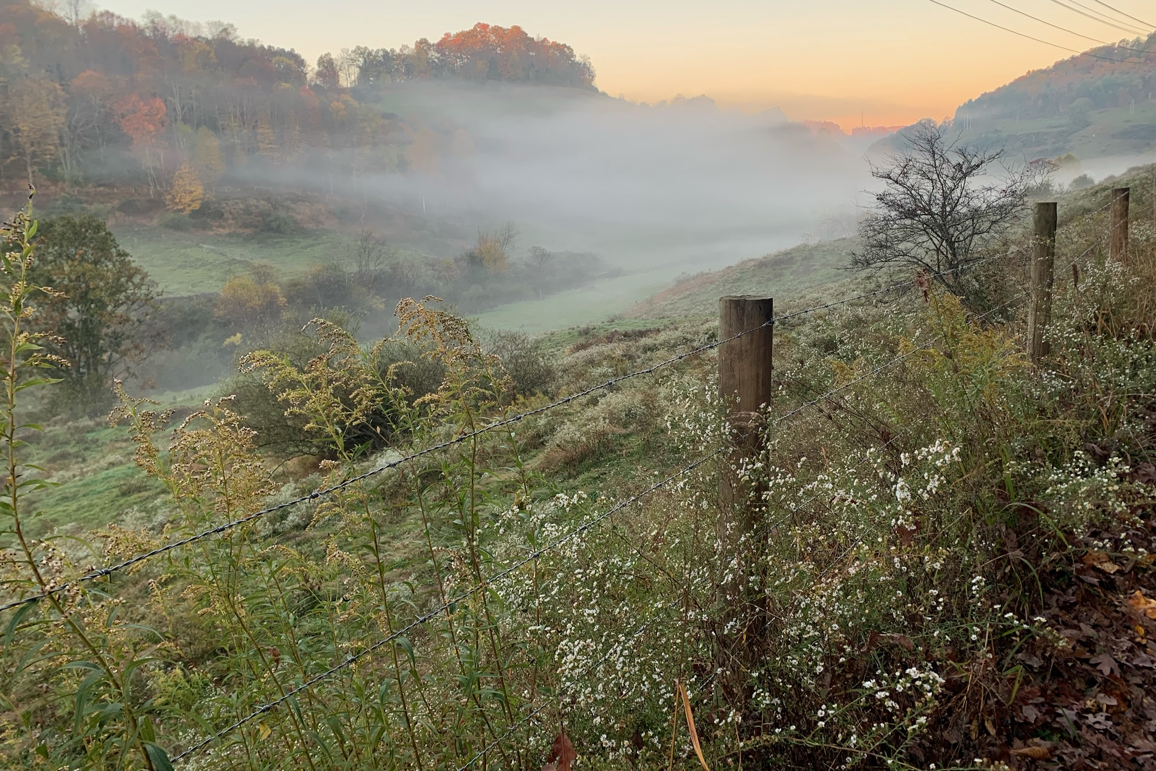

__________________________
The West Virginia Agriculture and Forestry Hall of Fame

The West Virginia Agriculture and Forestry Hall of Fame is an incorporated, independent, nonprofit, nonpartisan foundation, devoted to honoring those West Virginians who have made outstanding contributions to the “establishment, development, advancement or improvement” of the agricultural and forestry industries in West Virginia and the nation.
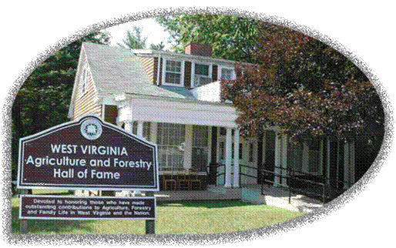

Nominations for 2021 induction to the WV Agriculture and Forestry Hall of Fame will be due February 15, 2021.
If you would like to nominate someone, the nomination form can be found at:

https://agriculture.wv.gov/wp-content/uploads/2020/08/2021-AFHOF-Application.pdf
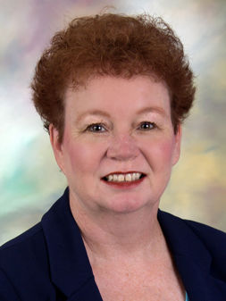
Two WV SAF Members Inducted into the WV Agriculture and Forestry Hall of Fame
Mary Beth Adams Mary Beth Adams was born July 8, 1958, at Seymour, Ind. She earned a B.S.F. degree in Forestry in 1980 from Purdue University and a then a Master’s Degree in 1982. She received her Ph.D. Degree from the North Carolina State University Department of Soil Science and School of Forest Resources in 1986. She conducted post-doctoral research for three years at the Oak Ridge National Laboratory Environmental Sciences Division. In 1989, she took a position with USDA Forest Service (USDA-FS) doing research on spruce and fir trees, and then became the USDA-FS Project Leader at its Northern Research Station in Parsons, a position she held for ten years. Since 2010, she was worked as a USDA-FS Research Soil Scientist at both Parsons and Morgantown. She has worked as an adjunct faculty member at WVU, Marshall University and Davis & Elkins College. She has also served on graduate student committees at WVU, Marshall, Howard University, the University of Pittsburgh and Virginia Tech University. She is a member of the Emeritus Visiting Committee to the WVU Davis College of Agriculture, Natural Resources and Design. She has also mentored students from Purdue and West Virginia Wesleyan College, and worked with Howard University and other Historically Black Colleges and Universities on a nationally recognized project entitled “Forest Health: Air Pollution Effects,” which provided a cooperative work experience for students and addressed USDA-FS research needs. She helped organize and conduct a variety of field tours and workshops throughout West Virginia and the country, and she served on the MeadWestvaco Wildlife and Ecosystem Research Forest Steering Committee. She was the Forest Service representative to the Chesapeake Bay Research Consortium Science and Technology Advisory Committee and served two years as the Chair of the Forest Service’s Experimental Forests and Ranges Chartered Working Group. She served on the Governor’s Panel on Mining, Timbering and Flooding Forest Hydrology Subcommittee, established following devastating and controversial flooding in the southern coalfields in 2001. She has edited a half-dozen journals and has nearly 160 papers to her credit. She has held leadership roles in a wide variety of professional organizations, particularly the Soil Science Society of America. Numerous organizations have presented her with awards of service and appreciation. The Purdue University School of Agriculture named her to its 2016 class of Outstanding Alumni. She is a Board Member for the Randolph County Habitat for Humanity, music director at her church, a member of the Elkins Kiwanis, and a Board Member for the Augusta Youth Ballet who has played the “Mouse King” for many years in the group’s annual production of “The Nutcracker”.

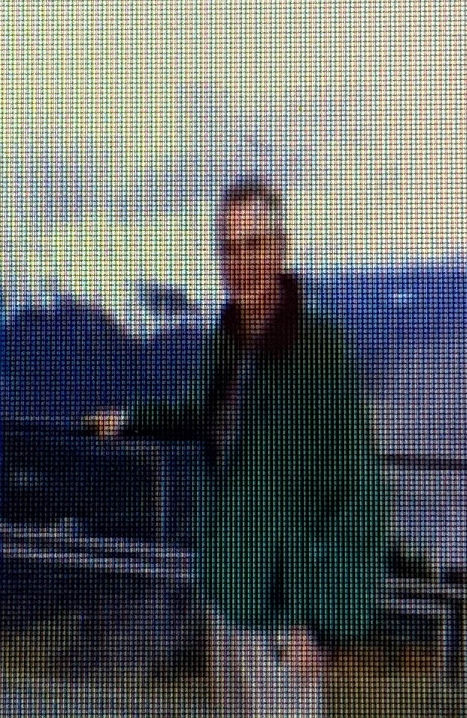
https://agriculture.wv.gov/wp-content/uploads/2020/08/HOF-2020-Adams.pdf

Terry Jones Terry Jones was born in Charleston, but moved to the New Jersey area, where he graduated from high school in 1972. He returned to attend WVU, where he earned a B.S. in Forest Research Management in 1976. He has held a variety of positions throughout his career, starting with New Jersey Division of Parks and Forestry in 1976, followed by short stints with the WV Division of Forestry in Braxton and Clay counties, and another move to New Jersey as a State Lands Forester. He returned to West Virginia for good in 1979, taking a position as the Lewis County as a Service Forester with the state Division of Forestry, then in the Department of Natural Resources (WVDNR). From 1985-88, he worked as a Water Resources Inspector for WVDNR. He transferred to the WV Division of Forestry in Randolph County as the Service Forester there. He became a State Lands Forester in 2002. In 2005, he was named the Wildlife Staff Forester and National Forest Coordinator with the WVDNR Wildlife Resources Section. Following his retirement from WVDNR in 2015, he worked as a Silviculturist / Client Adviser for Landmark Forestry in Horner, and started his own consulting firm, Rich Mountain Forestry LLC, the year after that. He has served on numerous committees involving best management practices and urban forestry. He has conducted several landowner tours and educational sessions. He assisted for several years with the National 4-H Forestry Invitational, the “National Championship of 4-H Forestry,” held annually at Jackson’s Mill. An avid outdoorsman, he coordinated and developed a statewide timber sale program that emphasized wildlife habitat creation and contracted wildlife management areas. He is a member of the Ruffed Grouse and American Woodcock Society, a member of the Rocky Mountain Elk Foundation and a member of Ducks Unlimited. He is a Registered Professional Forester in West Virginia, a member of the WV Forestry Association Board of Directors and a member of the Society of American Foresters. He was the Area 3 Chairman of the West Virginia Tree Farm Committee, and Past President of the Rich Mountain Battlefield Association. He was named the WV Division of Forestry District Three Employee of the Year in 1994, and received the WV Wildlife Federation Achievement Award in 2006. The Society of American Foresters presented him with its 2013 Presidential Field Forester Award, Allegheny Section. The West Virginia Forestry Association named him Forester of the Year in 2009.

https://agriculture.wv.gov/wp-content/uploads/2020/08/HOF-2020-Jones.pdf
In Memoriam
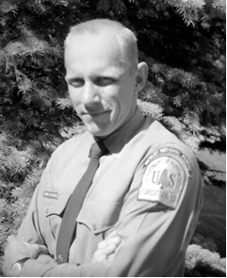
Harry B. Mahoney departed this life on Saturday, August 22, 2020. Born May 14, 1932 in Williamsport, Pennsylvania, he grew up in and around New York City.
He was a graduate of Yale University in New Haven, CT where he received a master’s degree in Forestry. After graduation, Harry worked as a Forester on the Oak Ridge RD of the Willamette NF. He worked there for a couple years in a variety of timber-related tasks before being drafted into the US Army. After his military service, he returned to the Willamette NF. In 1960 he became a Forester on the Marlinton RD of the Monongahela NF in Marlinton, WV, and in 1962, he became the District Ranger for the Cheat Ranger District in Parsons. While hiking with a group to Seneca Rocks, he met Lois Louise Lilly. They were married in Elkins in March 1965. In 1979, he was promoted to the Supervisor’s Office in Elkins, WV, where he served as the coordinator for the Highland Scenic Parkway Project, and for the Wild and Scenic Rivers program, among other jobs.
Harry was perhaps the most reliable source of historical information about the Monongahela NF and could always be counted on to present the facts accurately and with a warm sense of humor. An avid spelunker and bat enthusiast, in 1963, he discovered and named “My Cave” in Pocahontas County. In addition, he enjoyed skiing, hiking, rafting, backpacking, and camping with his family. Harry is survived by his 3 children, 4 grandchildren, nieces and nephews and many friends.
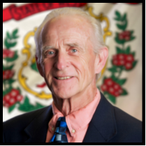
Barry Lester Cook, age 70, of Beckley, WV passed away at Charleston Area Medical Center General Division on Saturday, May 9, 2020. Born on May 10, 1949 in Williamson, WV, he was the son of the late Lester H. Cook and Vicie Catron Cook.

Barry, Director, State Forester of the West Virginia Division of forestry, was a seasoned forester of 45 years, a military veteran, and a West Virginia native. He was a 1967 graduate of Williamson High School. He earned his Bachelor of Science degree in Forest Management from West Virginia University in 1971 and obtained his Master of Business Administration degree from Duke University in 1994.
Director Cook started his forestry career as a logging superintendent for Weyerhaeuser Company in Plymouth, North Carolina. In 1975, He accepted a position with J.P. Hamer Lumber Company as a procurement forester, a position he held until 1978 when he became the procurement manager for Coastal Lumber Company. Cook spent the next 26 years accelerating through the leadership rank until he resigned in 2002 as their Vice-President of Operations to become President of Forest Products Group, an arm of Kimball International. Barry, and his wife Donna, then purchased and successfully operated Indiana Hardwoods headquartered in Chandler, Indiana. In 2007, the Cook Family relocated to Beckley, West Virginia, to afford Barry the opportunity to personally oversee the acquisition of Indiana Hardwoods by Cranberry Lumber Company. Since that time, he has consulted on various forestry projects as owner of Cook Natural Resources.
Prior to being appointed by Governor Jim Justice to serve as West Virginia’s State Forester, Director Cook served on executive committees and boards for various organizations including, the Hardwood Manufacturing Association; the West Virginia Forestry Association; Pioneer Southern Company; Coastal Lumber Company; Chocoyotte Country Club; and, Gutchess Lumber.

https://www.roseandquesenberry.net/obituary/barry-cook
--------------------------------------------------------------------------------------------------------------------------------------------------
Tom Cover Appointed as Director of the WVDOF
After the untimely passing of WVDOF Director, Barry Cook, Tom Cover has been appointed to fill this position. Tom has over 40 years of experience in forest industry, most recently as the Regional Forester for Region 4 of the West Virginia Division of Forestry.
Glenville State College Offers Online GIS Certification Program
The Online Certificate in Geographic Information System (GIS) will prepare students for work in the GIS industry with a focus on mapping, visualization, processing and analysis of geospatial data. Geospatial technology is a field that involves global positioning systems, geographical information systems and remote sensing. This technology offers an innovative way to combine information and maps to produce informational tools to help manage our communities, environment, natural resources and industries. The online Certificate program is designed for traditional students from academic departments other than the Department of Land Resources, non-traditional students and those who are already in the workforce to enhance skills, advance career and increase competitiveness to meet the challenges of working in this growing field or to continue their education within the geospatial and natural resource management disciplines. Faculty will work collaboratively with industry partners to develop hands-on projects and experiential learning that simulate real-world solutions to industry problems.

Program Requirements
NRMT 234 | GIS Applications I | 3 hours
NRMT 125 | Computer Assisted Mapping | 3 hours
NRMT 334 | GIS Applications II | 3 hours
LAND 244 | Remote Sensing and Aerial Photo Interpretation | 2 hours
LAND 243 | Introduction to Drone Technology | 1 hour
 |  | 12 credit hours
For more information, contact:
Rico M. Gazal, Ph.D, Department Head
Professor of Forestry
204 Waco Center
304-462-6372
Email - Rico.Gazal@glenville.edu
_____________________________________________
Benefits of being a Registered Professional Forester
Part of the benefit of attending SAF meetings/training is the acquisition of CFE’s needed to maintain your registration and/or licensing as a professional forester. In WV it is set out in H.B. 4447 30-19-6 (a) that registration is required “to use the title of “registered professional forester,” “professional forester,” “forester” or other title connoting to the general public that the applicant is a registered forester qualified to perform professional forestry services.”
The requirements and forms needed for registration can be found at: http://www.wvlicensingboards.com/foresters/registration.cfm . Renewal forms and requirements can also be found using this link. All renewals including CFE requirements are due by June 30th.
_____________________________________________


Engage. Educate. Inspire.
West Virginia has successfully utilized Project Learning Tree within classrooms and group settings since 1976. Project Learning Tree is a nationwide award-winning environmental education program that acts as a “window to the world” to engage children in learning – both inside and outside. Designed for teachers, educators, parents and other community leaders, this program provides professional training, integrated lesson plans and a variety of resources.
Individuals participating in Project Learning Tree are professionally trained in effective and engaging methods for teaching youth about the world around them and their place within it.

Children from preschool through 12th grade benefit from the hands-on learning that helps them excel in reading, writing, math, science and social studies. Students gain awareness of their surroundings. They learn to think critically and responsibly, and they learn to respect the opportunities our trees and forests provide, as well as the protection they require.

Want to learn more about PLT in West Virginia?
Visit the West Virginia PLT Website and contact:
Linda Carnell
West Virginia PLT State Coordinator
West Virginia Division of Forestry
One Depot Street
Romney, WV 26757
304-822-4512
Linda.O.Carnell@wv.gov
_____________________________________________

 https://www.facebook.com/WVSAF/
Please visit and “Like” WV Division of the SAF Facebook page and share it with your friends. Share your forestry activities and perspectives by commenting and posting.
We would love to see what you're up to!
As a member of our society you are encouraged to connect and engage with others through or Facebook page.

ROBERT BURNS OF THE SAF WV DIVISION

RECEIVES NATIONAL AWARD
The Society of American Foresters recognizes excellence and outstanding achievements of individuals and organizations in the field of forestry and natural resources. Each year, through its 14 national, Presidential Field Forester, and Fellow awards, SAF honors scientists, researchers, educators, innovators, leaders, communicators, field foresters, and others that have made significant impact on forestry in the United States and internationally.

Award in Forest Science

Robert Burns
Recognizes distinguished individual research in quantitative, managerial, and/or social sciences leading to the advancement of forestry.
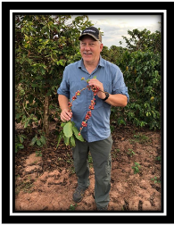
A long-time SAF member, Robert Burns is director of and professor at West Virginia University’s School of Natural Resources and an interdisciplinary social scientist whose research focuses on human interactions with natural resources. He is dedicated to merging research in outdoor recreation with that of scientists from other disciplines and develops relationships that breed success for all. A researcher of international reputation, he is an extremely hard worker and has maintained active research in Brazil and the US – a considerable effort requiring travel, proficiency in another culture and language, and endless energy.
He took over as director of the Division of Forestry about a year before COVID burst on the scene. He has continued to do what it takes to get the job done, while leading the division calmly and diligently through these interesting times. Robert brings impactful research, scholarship, skills as an educator, and passion for collaboration across the globe to the field of forestry.
Robert Burns is one of those stereotypical “quiet” people – soft spoken, yet creating a tremendous impact in his work. He isn’t flashy or congratulatory, he just gets the job done. – Mary Beth Adams
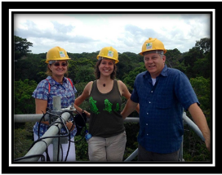
A few words from Robert Burns:
I am honored and humbled to receive this award. It is the many successes of the talented group of students, faculty members, instructors and staff at West Virginia’s Division of Forestry and Natural Resources that allows me to receive this award. As a social scientist, I have the opportunity to study and learn about the human dimensions of forestry, energy land management, outdoor recreation, fisheries and wildlife, and wood science technology. I marvel at the applicability of our research findings, and the unique role that humans play (both positive and negative) in our forested landscapes and adjacent lands and waters.
As we struggle to find our “new normal,” our forested landscapes will increase in value to people in many ways. We will need to understand more about future threats to our land and water settings, including climate change, invasive species, wildfire impacts, and direct negative human influences such as unmanaged recreation and unsustainable harvesting. However, our strengths are many, and with positive, educated people who care about our lands and waters, we can look to the increased efficiency of feedstock for bio-energy, to providing outstanding recreational opportunities, sustainable forestry, and well-managed ecosystems that support our wildlife and fisheries resources. It is up to us to make sure the strengths outweigh the threats, and we are poised to do so. Our hope for a brighter future for the field of forestry is seen in the young faces of our students at the SAF conference, and in our federal, state and private forest resource managers. I am proud to represent each of them.
Top photo—Robert Burns discussing agritourism with coffee plantation owner in Parana state, in the south of Brazil.
Bottom photo—Robert Burns and academic partners from Ponta Grossa State University (Brazil) and Duke University visiting the Large-Scale Biosphere-Atmosphere Experiment in the Amazon on the Tapajos National Forest, state of Para, Brazil.
Photos courtesy of Robert Burns
Reprinted from SAF: https://www.eforester.org/Safconvention/Wall_of_Honor/safconvention2020/Events/Wall_of_Honor.aspx?hkey=6f501b6d-91b0-4647-ac95-587db5770d82

DO YOU KNOW SOMEONE WHO SHOULD BE RECOGNIZED FOR  THEIR SERVICE AND ACHIEVEMENTS?

National Awards, Fellow Nominations

SAF Introduces Three New Awards
Time is running short to identify and nominate your worthy peers for the service and contributions they provide to the Society and the forestry profession. Nominations will be due March 15, 2021. Three new awards have been added to the suite of national awards to provide for recognition of excellence in the areas of student leadership, leadership in diversity, and leadership in employer support. The three new awards are the Diversity Leadership Award, Employer Leadership Award and Student Leadership Award.

Nominations for National Awards
Please contact Lori Rasor at rasorl@safnet.org with any questions,
Additional information about National SAF Awards is available at: https://www.eforester.org/Main/Community/Awards___Fellows/Awards.aspx?hkey=08ba93f9-1ce4-4faf-ae09-8917c9f00e94

Fellows
One of the highest honors for members of the Society, the rank of Fellow is an exceptional recognition bestowed on a member by his or her peers for outstanding contributions and service to the SAF and the profession.

Forest Science and Technology Awards

Award in Forest Science
The Award in Forest Science recognizes distinguished individual research in any branch of the quantitative, managerial, and/or social sciences leading to the advancement of forestry.

Barrington Moore Memorial Award
The Barrington Moore Memorial Award recognizes outstanding achievement in biological research leading to the advancement of forestry.

Technology Transfer Award
The Technology Transfer Award recognizes outstanding performance in the areas of technology transfer, implementation and extension.

Communications Awards

Outstanding Forestry Journalism Award
The Outstanding Forestry Journalism Award recognizes high quality journalistic coverage of topics that increase the American public's understanding of forestry and natural resources.

W. D. Hagenstein Communicator Award
The Hagenstein Communicator Award recognizes an SAF member who leads innovative and exemplary communications initiatives and programs that increase the general public's understanding of forestry and natural resources.

Professional Development Awards

Carl Alwin Schenck Award
The Carl Alwin Schenck Award recognizes devotion and demonstrated outstanding performance in the field of forestry education.

John A. Beale Memorial Award
The John A. Beale Memorial Award recognizes outstanding efforts over a sustained period by an SAF member in the promotion of forestry through voluntary service to the Society.

Gifford Pinchot Medal
The Gifford Pinchot Medal recognizes outstanding contributions by a forestry professional in the administration, practice, and professional development of North American Forestry.

Sir William Schlich Memorial Award
The Sir William Schlich Memorial Award recognizes broad and outstanding contributions to the field of forestry with emphasis on, but not limited to, policy and national or international activities.

Honorary Membership
The Honorary Membership Award recognizes individuals whose contributions to forestry are viewed as outstanding by their peers.

Young Forester Leadership Award
The Young Forester Leadership Award recognizes outstanding leadership by a young forestry professional in the development and promotion of an individual program or project, or for a sustained leadership role benefiting the practice of forestry and the Society of American Foresters.

Leadership Awards

Diversity Leadership Award
The Diversity Leadership Award recognizes outstanding individual achievement leading to innovative and exemplary diversity and inclusion efforts.

Employer Leadership Award
The Employer Leadership Award recognizes an employer that demonstrates leadership through consistent support of employee participation in SAF and broad engagement in the profession.

Student Leadership Award
The Student Leadership Award recognizes individual student achievement and leadership at the local, regional, or national level.

Presidential Field Forester Awards
The Presidential Field Forester Awards recognize foresters who have dedicated their professional careers to the application of forestry on the ground using sound, scientific methods and adaptive management strategies. The awards are presented to individuals who have displayed uncommon talent, skill, and innovative methods to achieve a record of excellence in the application of forest management.

Outstanding SAF Student Chapter Award
The Outstanding SAF Student Chapter Award recognizes the outstanding SAF student chapter in the nation and its faculty representative during an academic year.
Three student chapters are recognized annually during the SAF National Convention. The first-place student chapter will receive a $500 honorarium. All three student chapters will be recognized in The Forestry Source. The school's department head and/or dean, the university president, and the SAF faculty representative will receive notification of the award.
______________________________________________________________________________________
More information regarding Allegheny SAF Awards can be found at: http://www.alleghenysaf.org/awards
Allegheny SAF Awards
The deadline for annual award nominations is December 5.
Presidential Field Forester
Robert W. Bauer Outstanding Service to Forestry
Forester of the Year
Student Leadership Award
https://www.alleghenysaf.org/awards
Contact: Kelsey Delaney at delaneyk@safnet.org or call (866) 897-8720 ext.202.

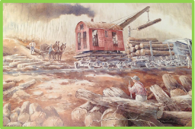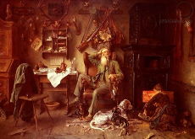
For Sale - "West Virginia Logging" and “Forester at Home” Prints
The “West Virginia Logging” unframed prints are available for $35.
Those interested should contact Charles Copeland at: Charles.R.Copeland@wv.gov

“FORESTER AT HOME” prints are also still available from the West Virginia Forestry Association has teamed with the WV Society of American Foresters to sell the "Forester at Home". Unframed: $85 Shipping and Handling. Contact the WVFA office to order your copy or for more information at 304-372-1955.
____________________________________________

WV WOMEN OWNING WOODLANDS UPDATE

The WV Women Owning Woodlands (WV WOW) program is still gaining new members. Due to the pandemic, our weekend retreat has been postponed twice. We currently have facilities reserved for April at Watoga State Park, but may have to revisit how we will conduct this face to face workshop. Members share on the group’s private Facebook page and receive regular reminders of current events and virtual learning opportunities. If you know of women woodland owners who may be interested in learning more about the group and opportunities to network with other women woodland owners, please have them contact us at: wvwomenowningwoodlands@gmail.com and/or request membership on the WV Women Owning Woodlands Facebook page.

BOOK REVIEW – Ebooks.com

Dirt

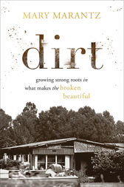
Growing Strong Roots in What Makes the Broken Beautiful

Mary Marantz – Daughter of WV Logger William E. Bess Jr., Richwood, WV

Dirt is a story about the places where we start. From a single-wide trailer in the mountains of rural West Virginia to the halls of Yale Law School, Mary Marantz's story is one of remembering our roots while turning our faces to the sky. From growing up in that trailer, where it rained just as hard inside as out and the smell of mildew hung thick in the air, Mary has known what it is to feel broken and disqualified because of the muddy scars leaving smudged fingerprints across our lives. Generations of her family lived and logged in those hauntingly treacherous woods, risking life and limb just to barely scrape by. And yet that very struggle became the redemption song God used to write a life she never dreamed of.
Mixed with warmth, wit, and the bittersweet, sometimes achingly heartbreaking places we go when we dig in instead of give up, Dirt is a story of healing. With gut-wrenching honesty and hard-won wisdom, Mary shares her story for anyone who has ever walked into the world and felt like their scars were still on display, showing that you are braver, better, and more empathetic for what you have survived. Because God does his best work in the muddy, messy, and broken--if we'll only learn to dig in.

 MARK YOUR CALENDARS…….
Upcoming Events
West Virginia Woodland Stewards Seminar
AGENDA for Wednesday evening; DECEMBER 16, 2020; 6pm-8:30pm
Continuing forestry education credits: Applied for
ONLINE meeting via Zoom—Links will be furnished to those who RSVP
To register, go to:
https://wvu.zoom.us/meeting/register/tJEof-Csrj0tGdcpDLBegH8xXSjfMSRbxru_

AGENDA
6:00 pm - NEPAssist - Susan Paret— NEPA Compliance Division, U.S. Environmental Protection Agency
6:30 pm - Black Walnut Update - Erin Shaw, John Kelsey, and Jared Beard
7:00 pm - BREAK/Questions and Answers
7:15 pm - The Backyard Woodlot Classroom: Remote Learning at its Best
Kevin Johnson—Director of Environmental Ed for Appalachian Headwaters
7:45 pm - Ask a Logger—Bernardo Brunetti, Maryland Master Logger
8:15 pm - Questions and Answers
8:30 pm – Depart

For more information, contact: Dave McGill – dmcgill@wvu.edu / 304-293-5930

Upcoming SAF National Conventions
2021 – Sacramento, CA
November 3 - 6, 2021

2022 - Allegheny SAF will host the
2022 SAF National Convention in Baltimore, MD
September 18 - 23, 2022
_____________________________________________________________________________
Although there aren’t many details with regards to plans for the 2022 National SAF Convention, there will be many opportunities to volunteer to help make this meeting a success!
_________________________________________________________________________________________

Check out the SAF Website at: http://www.safnet.org/
_______________________________________

Do you want to get involved?
During the executive committee and business/training meetings many ideas are discussed. WV Chair, Todd Lotter, outlines many of these thoughts in his letter that appears earlier in this newsletter.

Are you interested in helping to develop these ideas?
If so, contact Todd Lotter at: Todd.Lotter@afmforest.com

____________________________________________________________________________________________________________________________________________

- HELP WANTED……………………………….
As the Communications Chair, I welcome any input you can provide regarding content suggestions, upcoming events, awards, obituaries, etc.
Thank you --- Barb McWhorter (mcwhorte@citynet.net)
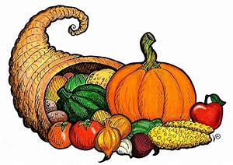 Give Thanks

